**Design Document**

## **1)Module Description:**

The different modules required for the QRT Chatbot are:

* Symptom Identification process: Raw data & chat processing
* Sentimental Analysis process

Symptom Identification process: This involves collection of chat data from users along with other contextual information such as location, time, etc. This process is necessary for the chatbot to make intelligent choices in the way it interacts with users. It involves breaking down the users chat into discernable sequences to recognize patterns in language like intent, targets, subject, etc. The chatbot should be able to process the data along with the contextual data and determine the intent of the users chat and to identify if the user has any detectable symptoms of COVID-19.

Sentimental Analysis: This involves breaking down the patterns in sentences to try and determine emotion behind the chats. This is necessary to provide users with appropriate feedback from the chatbot. It involves tracking two states for users, the emotional state of the user and also whether a user is COVID-19 positive or not. This is necessary as these two states fundamentally determine how the chatbot should interact with users.

Intent classification is done using Support Vector Machines (SVM) classifier because it requires less training to guarantee confident intent classification.

## **2)Data Flow Diagrams:**

**DFD level 0:**

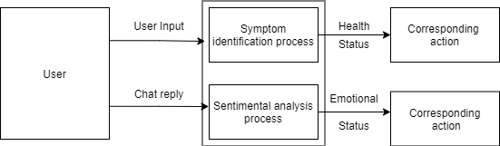

**DFD level 1:**

**Module 1: Symptom Identification process**

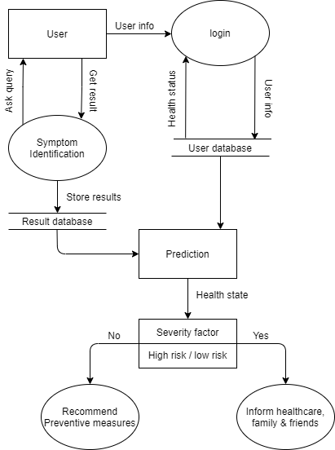

**Module 2: Sentimental Analysis Process**

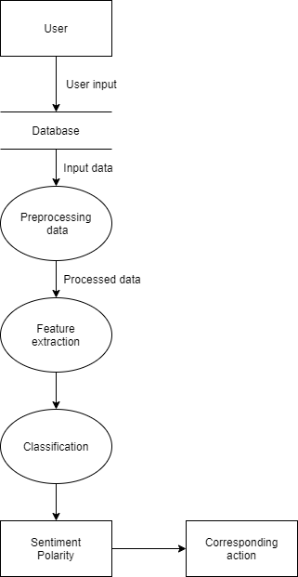

**DFD level 2:**

**Training:**

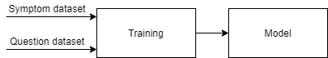

**Testing:**



**Prediction:**

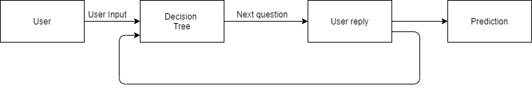

## **Software Architecture:**

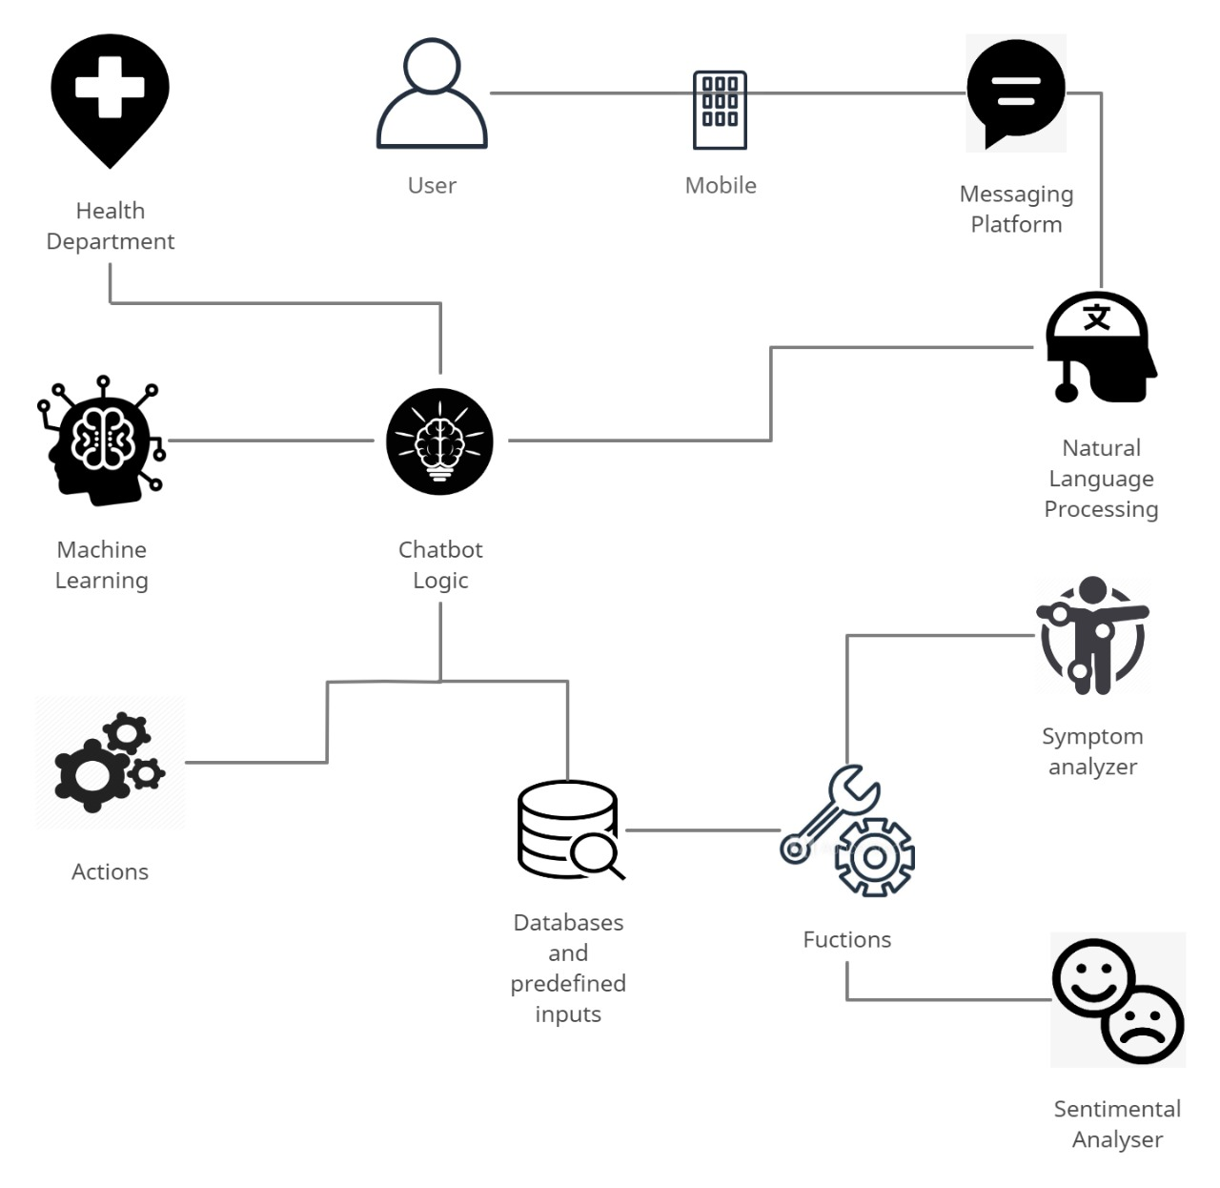

## **Use Case Diagram:**

